**Database Resource Management Application**

**Final Report**

Ganghuan Huang (James)

Haoying Li (Henry)

9 June 2021

**Introduction**

Our main purposes of developing this database resource management application are to provide an easy to use system that monitors and controls resource usage, as well as provides flexible query access and user friendly interface.

**Architecture Overview**

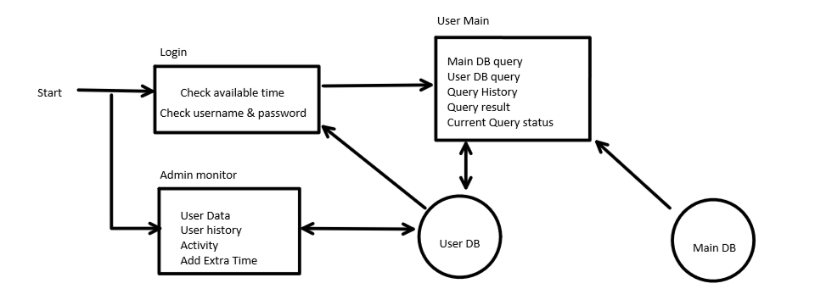

**Front End Design**

We have designed three window forms for our project. A user login window would be displayed at first upon opening the application. Users are able to enter their credentials to login into the system and have access to the databases. Another window which is called admin monitor would show up as well as starting the application. This form is designed for administrators to view all users’ information and monitor signed in users’ activities. It also grants administrators the ability to add additional access time for the users. After users have successfully signed in, the main application window would be provided to the users. Users are able to execute SQL queries on the main database and user database if they have previous queries results stored. There is a Status Log which notifies users the current status of the application. The History Console shows information of all the queries executed in the past and also updates when users successfully execute queries on the main database. At the bottom of the window, there is a SQL Result component for showing the data result after users execute queries.

**Database Design**

We created two sample databases as we developed the system. The main database is designed for users to execute read-only SQL queries. The other database stores all of the information related to the users. It contains users’ credentials for authentication of login; a history table for each user which stores the dates, time, duration and query result table names of all the previous SQL queries; and tables for each successful query results on the main database.

**Development Tools**

During the development of our system, we have used C# for the frontend and UI design and connect to the databases. For the backend, we used SQL Server Management Studio to create databases. We used Github to store and update our codebase. Teams, and Discord are the tools we used for communication.

**Screenshots of Demo**

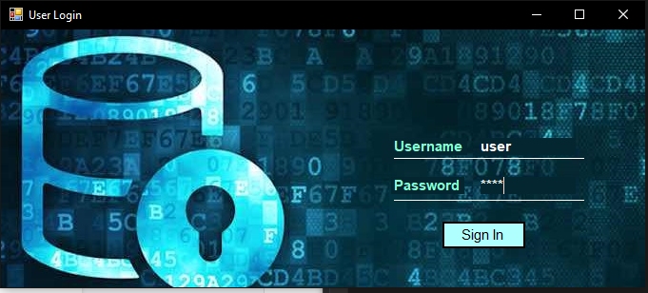

User Login Form

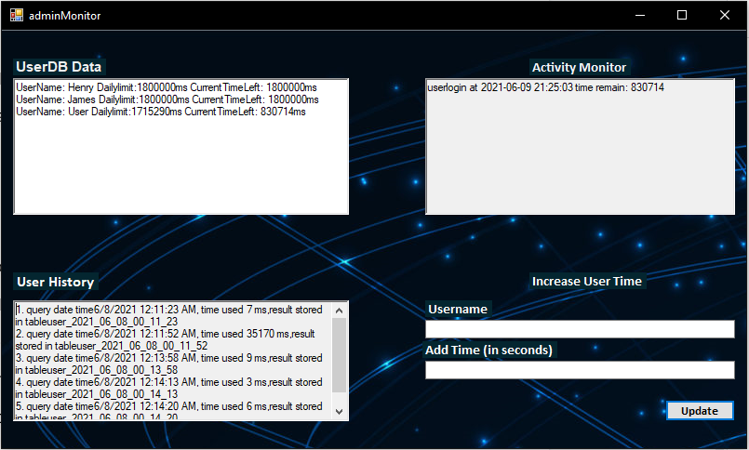

Admin Monitor

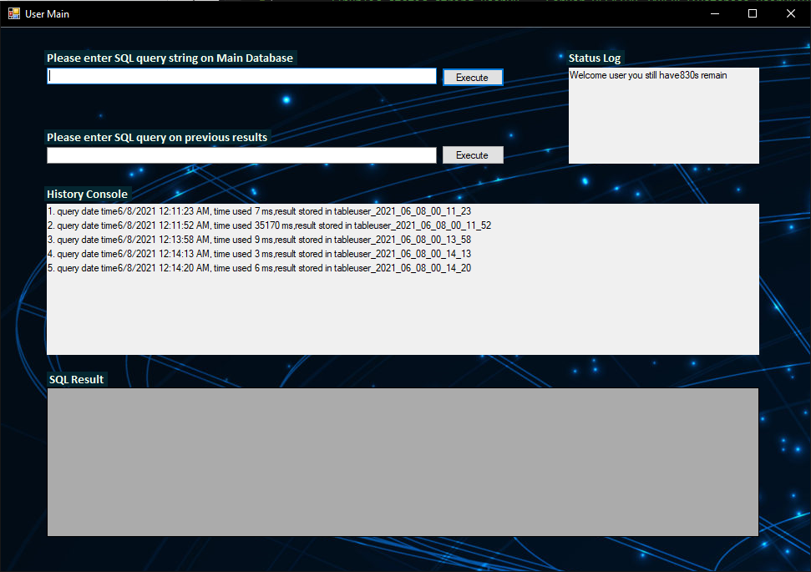

Main Form for User

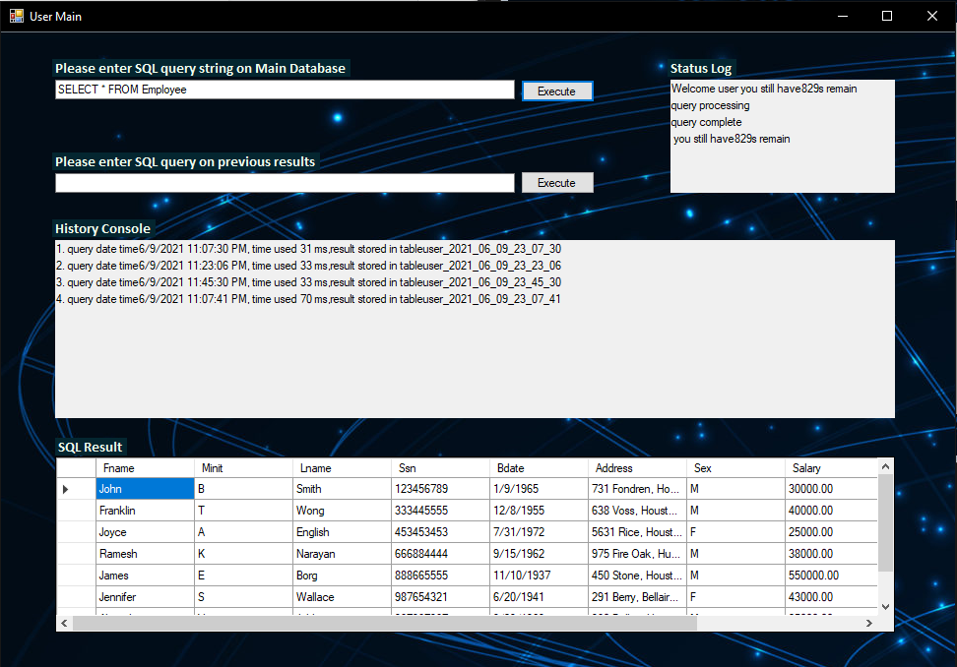

Example of executing query on main database